SECTION 1: Hands-On Demonstration

Part 1. Harden a IIS Web Server

1. the successful installation of the Web Server (IIS) role (screen capture):

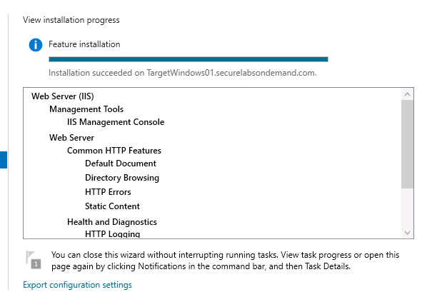

2. both changes to the Advanced Settings (screen capture):

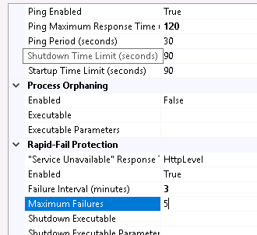

Part 2. Harden an Internet Explorer browser

1. the change to the Trusted Sites dialog box (screen capture):



1. the google.com website in the browser window (screen capture):



SECTION 2: Applied Learning

Part 1. Harden a IIS Web Server

1. the new HTTPS binding (screen capture):

2. the purpose of the Managed pipeline mode settings:

Part 2. Harden an Internet Explorer browser

1. the time stamped cookie information (screen capture):

2. the TargetWindows01 website in the browser window (screen capture):

SECTION 3: Observation Summary

We RDP into machine1. We go to run roles and features of server manager in order to add IIS. We make sure the Directory Browsing is disabled. We change the logging directory. We than change settings from applicaton protocols – advanced settings and save them. We change the internet explorer security settings to prevent the network attacks that use these vulnerabilities.

We RDP into machine1. We go to run roles and features of server manager in order to add IIS.